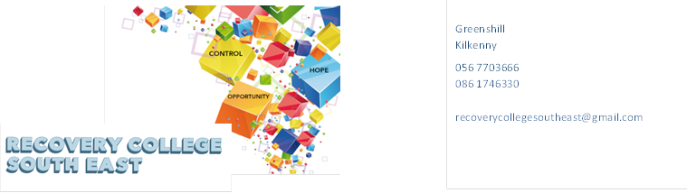

Greenshill

Kilkenny

R95 YYC0

Tel: 086 1746330

Email: recoverycollegesoutheast@gmail.com

Website: www.recoverycollegesoutheast.com

|  |  |  |  |
| --- | --- | --- | --- |
| **Recovery College South East – Wexford**  **Recovery Education Programme: April- June 2025**  **You are invited to join us on our new Recovery Education Programme.**  **For more detailed information on the workshops, please go to the Workshop Section of our Website –** [www.recoverycollegesoutheast.com](http://www.recoverycollegesoutheast.com).)   1. **Complete the attached enrolment form and email it to the Recovery College South East at** [**enrolrecoverycollegesoutheast@gmail.com**](mailto:enrolrecoverycollegesoutheast@gmail.com) **or** 2. **Phone us on 086 1746330 to enrol** | | | |
| **VENUE** | **WORKSHOP NAME** | **DATES** | **TIME** |
| **February - March 2024** | | | |
| **Link,**  **Enniscorthy,**  **Y21 R2R1** | **Personal Development**  **(8 week Workshop)**  Personal Development 8-week workshop is designed to help individuals unlock their full potential, create a positive mindset, and develop the skills necessary to achieve personal and professional success.  Whether you're looking to enhance your self-confidence, improve your emotional intelligence, or build healthy habits that promote growth, this course will provide the tools and strategies to transform your life. | **Every Wednesday**  **Starting From**  **30th April –**  **18th June** | **10.30am –12.30pm** |
| **VENUE** | **WORKSHOP NAME** | **DATES** | **TIME** |
| **April - June 2024** | | | |
| **Wexford Mental Health Association’**  [**Henrietta St, Townparks, Wexford**](https://www.google.com/maps/place/data=!4m2!3m1!1s0x48681bc23e14b929:0x9cb2a5b35a88fd8b?sa=X&ved=1t:8290&ictx=111) **Town** | **Personal Development**  **(8-week Workshop)**  Personal Development 8-week workshop is designed to help individuals unlock their full potential, create a positive mindset, and develop the skills necessary to achieve personal and professional success.  Whether you're looking to enhance your self-confidence, improve your emotional intelligence, or build healthy habits that promote growth, this course will provide the tools and strategies to transform your life. | **Every Thursday**  **1stMay –**  **19th June** | **2pm-3.30pm** |

Greenshill

Kilkenny

R95 YYC0

086 1746330

recoverycollegesoutheast@gmail.com

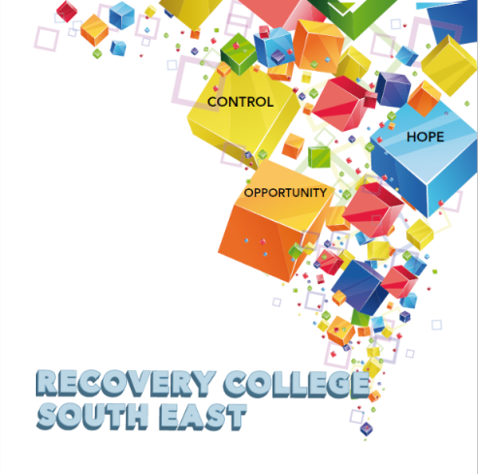

**Enrolment Form**

|  |  |  |  |
| --- | --- | --- | --- |
| **Course title** | **Commencement date** | **In-house or Online (Zoom)**  **Please tick your preference below** | |
|  |  | **In-house** | **Online (Zoom)** |
|  |  | **In-house** | **Online (Zoom)** |
|  |  | **In-house** | **Online (Zoom)** |

|  |  |  |
| --- | --- | --- |
| **PLEASE COMPLETE USING BLOCK CAPITAL LETTERS** | | |
| **Surname:** |  | |
| **First name(s)** |  | |
| **Address:** |  | |
| **Telephone:** | **Mobile** | **Home/Work** |
| **Email:** |  | |
| **Contact Details in Case of Emergency:** | **Name** | **Number** |
| **Where did you hear about the Recovery College** |  | |
| **Please tick the box that best describes you** | **Service User/Lived Experience_____________________________________  Family Member/Carer____________________________________________**  **Service Provider (Area of Work) __________________________________**  **_________________________________________________________________ Other (Please specify)/Prefer Not to Say____________________________________________**  **__________________________________________________________________** | |
| **All our workshops are based around discussion and group work. Pen and paper would be helpful to have to hand for participants.** | | |

***All our Workshops are free of charge.***

|  |
| --- |
| **Are you happy for us to contact you periodically by email, post or text about different events, workshops, surveys in relation to the Recovery College South East? (Please tick this box if yes.)** |

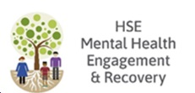**Student Signature _________________________________ Date _________________________**



*Recovery is moving on, achieving and learning, being the best and the best that I can be with confidence” Mental Health Discussion Group Clonmel 2013*

